Questions regarding PG5 Starter Training

Name:______________ Company:________________

1. With which tool in PG5 do you set the system time of the PCD?

* Device Configurator
* Fupla Editor
* Online Configurator
* Project Manager

1. With which tool in the PG5 do you define the hardware properties of the PCD?

* Device Configurator
* Fupla Editor
* Online Configurator
* Project Manager

1. What do you have to do before you download the program?

* Save
* Build
* First Save, then Build
* First Build, then Save

1. With which icon can you turn on the Online View in order to look at the program online?

* 













1. What kind of FBox is used first via an interface for all communication?

* HLK Init
* Call PB
* Init
* Memory

1. What is the name of the file extension of a page in the WebEditor?

* .jar
* .teq
* .html
* .tcr

1. What needs to be set in the settings of the button, so that it works as a button at all?

* String
* 2 Colors on Conditions
* Toggle
* PPO

1. What needs to be done before a project with Fupla program and Web Project can be downloaded?

* Only a Build in PG5
* Only a Build in WebEditor
* Build in WebEditor and in PG5
* Build in WebEditor or in PG5

1. How can you look at the Web Project “online“?

* By switching to the online mode in the PG5 Project Manager
* By switching directly in the WebEditor to online mode
* By opening the homepage with a Web-Browser
* With the shortcut Ctrl-Alt-O

1. How must be the S-Bus address of an energy meter and the connected PCD?

* same
* different
* Both between 0 and 10
* Both between 0 and 20

1. On which communication technology is the serial S-Bus based?

* CAN
* RS 485
* Profibus
* Ethernet

General questions about different topics

Electrical engineering

1. What does the following symbol mean?

* Button



* Switch
* Relay contact
* Fuse

1. What does the following symbol mean?

* Relay with switch-on delay



* Relay with switch-off
* Thermal relay
* Thermal fuse

1. What does the following symbol mean?

* Direct current machine



* Alternator
* Three-phase direct current machine
* Three-phase electric machine

1. What is the name of this circuit?

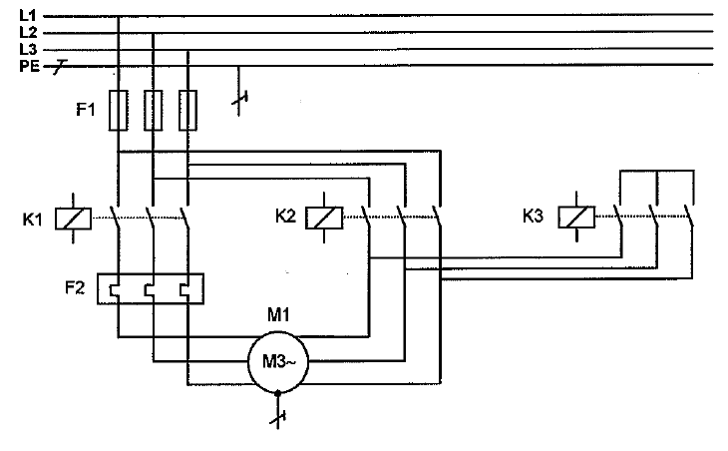

* Inverting circuit
* Dahlander pole changing
* Star-Delta connection
* Circuit for asynchronous motor with two separate windings

1. All lamps, H1, H2 and H3 are turned on. Which case occurs, if S3 is pressed?

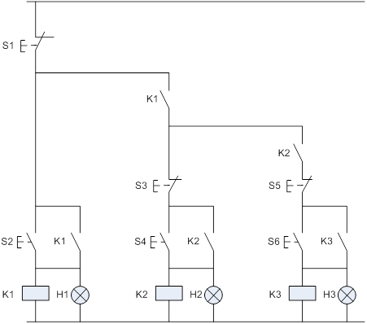

|  |  |  |  |
| --- | --- | --- | --- |
| **Fall** | **H1** | **H2** | **H3** |
|  | light | dark | dark |
|  | light | dark | light |
|  | light | light | dark |
|  | light | light | light |
|  | dark | dark | light |

Digital technology

1. 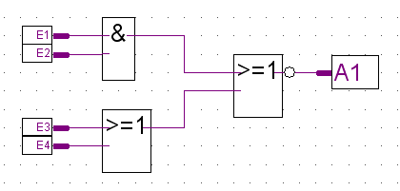Which row of the value table is correct for the logic?

|  |  |  |  |  |  |
| --- | --- | --- | --- | --- | --- |
|  | E1 | E2 | E3 | E4 | A1 |
|  | 0 | 0 | 0 | 0 | 1 |
|  | 0 | 0 | 1 | 1 | 1 |
|  | 0 | 0 | 1 | 0 | 1 |
|  | 1 | 1 | 0 | 1 | 1 |
|  | 1 | 1 | 1 | 1 | 1 |

1. 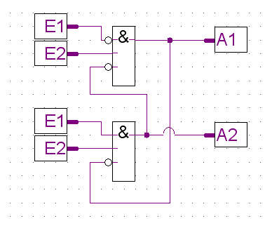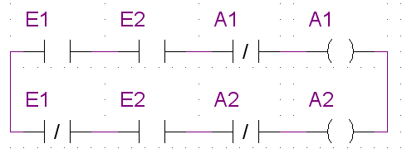Which contact diagram matches with the logic diagram?

* 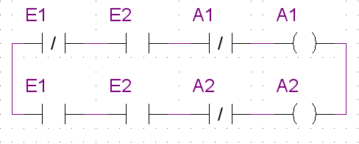
* 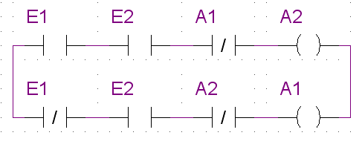

1. Which equation is true for the below circuit?

* 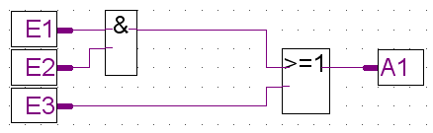A1 = A2
* A2 = A3
* A1 = A3
* 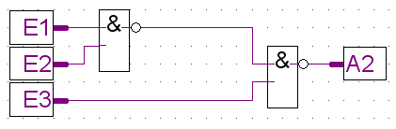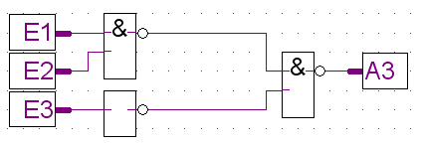A1 = A2 = A3

TCP/IP

1. What IP address must the PC have, in order to communicate with the PCD?

* 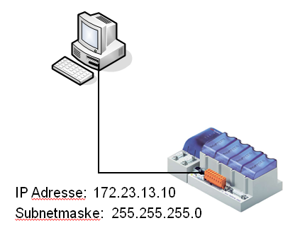172.23.13.10 / Subnet 255.255.255.0
* 173.24.14.11 / Subnet 255.255.255.0
* 172.01.01.00 / Subnet 255.255.255.0
* 172.23.13.54 / Subnet 255.255.255.0
* 172.23.135.4 / Subnet 255.255.255.0

IP address: 172.23.13.10

Subnet mask: 255.255.255.0

1. With which command can you control in the Windows prompt whether you can access with a PC via Ethernet the PCD?

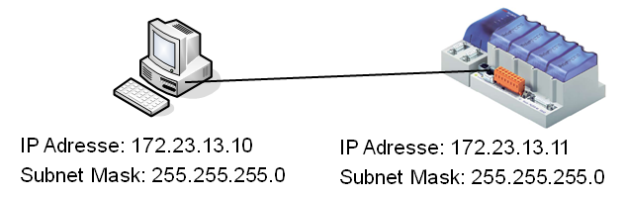

* ipconfig 172.23.13.11
* arp –a 172.23.13.11
* ping 172.23.13.11
* ping 172.23.13.10
* format c:

1. Which statement is true?

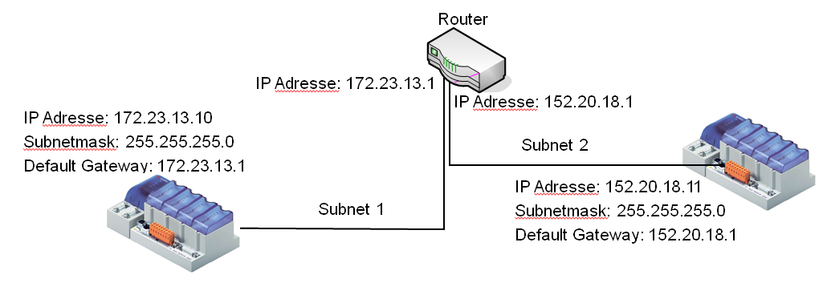

IP address: 152.20.18.1

IP address: 172.23.13.1

IP address: 172.23.13.10

Subnet mask: 255.255.255.0

Default gateway: 172.23.13.1

IP address: 172.23.13.10

Subnet mask: 255.255.255.0

Default gateway: 152.20.18.1

* These illustrated PCDs can communicate via the router with these settings
* These two PCDs can communicate directly via the Ethernet port without a router in between

Programming technique

1. How do you call the middle level of the automation pyramid?

* Intermediate level

management

level

?

field level

* Forest level
* Management level
* Automation level

1. How do you call the below programming style?

* 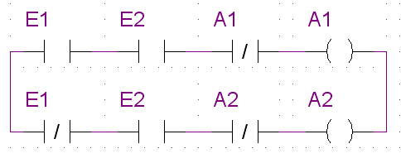Function plan
* Electric circuit diagram
* Instructions list
* Ladder diagram
* Sequential control

1. 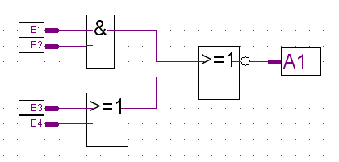How do you call the below programming style?

* Function plan
* Electric circuit diagram
* Instructions list
* Ladder diagram
* Sequential control

1. How do you call the below programming style?

* 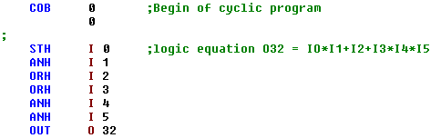Function plan
* Electric circuit diagram
* Instructions list
* Ladder diagram
* Sequential control

Heating Ventilation Air Conditioning / Control

1. What does the following symbol means?

* AC0010Air heater
* Air cooler
* Fire damper
* Cooling unit

1. What does the following symbol means?

* SE0121Temperature measurement
* Power measurement
* Pressure measurement
* Antifrost thermostat

1. What does the following symbol means?

* AR00412-way valve
* 3-way valve
* 4-way valve
* 4-way valve reduced

1. What is the name of this control?



* Room temperature control
* Supply air temperature control
* Outside air temperature control
* Heating control
* Room supply air cascade control

1. What is the name of this control?



* Room temperature control
* Supply air temperature control
* Outside air temperature control
* Heating control
* Room supply air cascade control

1. What is the name of this control?



* Temperature controlled fan control
* supply / retunr bypass control
* weather compensated supply water control
* heating control
* supply ait control